12 Days of Christmas Reading! 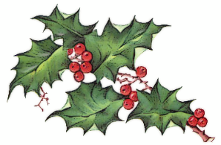

We are all Greta – Valentina Giannella 9781786276131
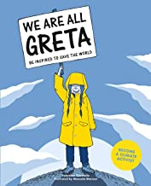
This book sets out the basic ideas required to understand climate change, explained in a scientific and accessible way and drawn from the most authoritative sources. With a chapter on key words and sites to help you understand the climate challenge and a list of websites to visit for further information, this is a book for young people, for parents, for grandparents and anyone having to answer direct and urgent questions about what must be done to protect our world.

Some places more than others – Renée Watson 9781526613684
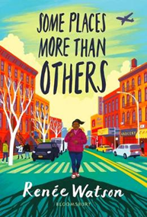
Amara knows exactly what she wants for her 12th birthday; to visit her father’s family in New York. She understands it will be very different to the small town she’s grown up in, but can’t wait to explore the big city and get to know her family properly. The trip is eye-opening in lots of ways as she learns more about her father and his childhood, about her family, and even her own history. Renée Watson shows us that families are complicated, that it’s never too late to change or make amends, and that we can all carry on learning even as we grow up. Quiet, though full of drama, and skilfully told, this is a touching and thought-provoking story with well-drawn, engaging characters; a book that will make a real impact on its reader.

Shadows of Winterspell – Amy Wilson 9781529018967
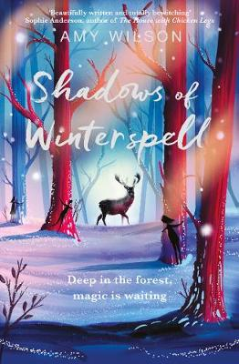
Enter the thousand worlds of Amy Wilson in her captivating novel which is sparkling with forest and magic. Stella has been living behind the magic of the forest for most of her life. Lonely, she enrols at the local school, and as she begins to make friends, she discovers that she is even more different than she thought. But as autumn turns to magical winter, Stella realises that uncovering her own family secret is the only way to release the forest from the grip of a dark and old magic.
A seasonal magical adventure from the critically-acclaimed Amy Wilson, author of A Girl Called Owl.

North Child – Edith Pattou 9781474958585

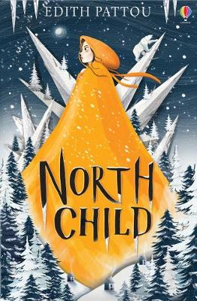
Perfect for Christmas! A beautiful, epic story of destiny, magic and love... Reborn for a new generation of readers. Rose is an unusual child, a North Child. For Rose was born facing north, and the old stories say she is destined to travel far from home on a dangerous journey. Making a pact with an enormous white bear, Rose travels on his back to a mysterious castle that holds a dark enchantment, a darker temptation, and the key to her true destiny...

The Sleeper and the Spindle – Neil Gaiman 9781408859650

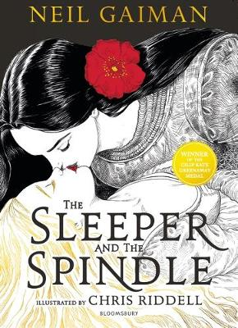
A thrillingly reimagined fairy tale from the truly magical combination of author Neil Gaiman and illustrator Chris Riddell, now available as a gorgeous paperback enhanced with gloriously vibrant red ink highlights. Weaving together hints of Snow White and Sleeping Beauty with a shimmering thread of dark magic, it will hold readers spellbound from start to finish.
On the eve of her wedding, a young queen sets out to rescue a princess from an enchantment. She casts aside her fine wedding clothes, takes her chain mail and her sword and ventures into the tunnels under the mountain towards the sleeping kingdom. This queen will decide her own future - and the princess who needs rescuing is not quite what she seems.
Twisting together the familiar and the new, this delicious, captivating and darkly funny tale shows its creators at the peak of their talents. Lavishly produced and packed with glorious Chris Riddell illustrations, this amazingly beautiful book makes a spectacular and magical gift.

Floodworld – Tom Huddleston 9781788004343
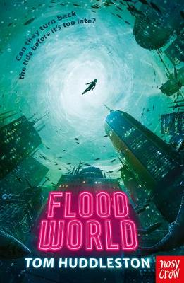
A thought-provoking, intelligent dystopian thriller. Set in a flooded future world, Tom Huddleston’s book is a thrilling adventure, in which two young people are caught up in a world of pirates, gangsters, power struggles and corruption. Kara and Joe live in a floating slum on the edge of what is left of London after rising seas have drowned our civilisation. They’ve always been told that the Mariners, gangs who live entirely at sea, are terrorists. But then Joe’s life is saved by a Mariner, who entrusts him with a secret map. It’s a story that poses questions about our future, individual responsibility and the morals of political activism. Timely, thought-provoking, and action-packed.

The Gifted, the Talented and Me – William Sutcliffe 9781408890219

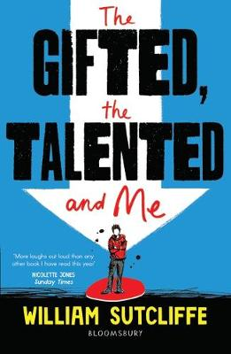
Laugh-out-loud funny and instantly recognisable - not since The Inbetweeners has a coming of age story been so irreverent and relatable. Fifteen-year-old Sam is not a famous vlogger, he's never gone viral, and he doesn't want to be the Next Big Thing. In fact, he's ordinary and proud of it. None of which was a problem until Dad got rich and Mum made the whole family move to London. Now Sam's off to the North London Academy for the Gifted and Talented, where everyone's busy planning Hollywood domination or starting alt-metal psychedelia crossover bands. Sam knows he'll never belong, even if he wanted to. And that's before he ends up on stage wearing nothing but a fur onesie ... A brilliantly funny look at fitting in, falling out and staying true to your own averageness. (14+). Shortlisted for the Warwickshire secondary book award 2020.
One Shot – Tanya Landman 9781781128510

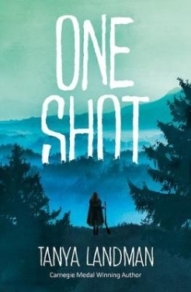
After the death of her beloved father, Maggie and her family are thrown into a life of destitution. With little income and no way to live off their poor land, Maggie tries to provide for her family the way her father always had - with his hunting rifle and whatever animals the forest would provide. But when her mother is confronted with her unladylike behaviour, Maggie is thrown into a life of unthinkable cruelty and abuse. With no one to care for her and only the hope of escape, all Maggie can do is survive.
Particularly suitable for struggling, reluctant or dyslexic readers aged 14+.shortlisted for the Warwickshire secondary book award 2020.

Toffee – Sarah Crossan 9781408868133

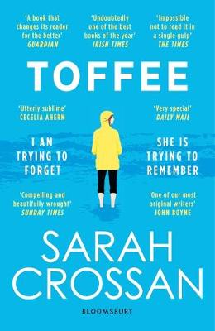
Another insightful and compassionate free verse novel from the queen of this admired form, this time exploring the transformative relationship between an abused runaway teenager and an elderly lady with dementia.
When Allison runs away from home she doesn't expect to be taken in by Marla, an elderly woman, who mistakes her for an old friend called Toffee. Allison is used to hiding who she really is, and trying to be what other people want her to be. So, Toffee is who she becomes. But as her bond with Marla grows, Allison begins to ask herself - where is home? What is a family? and most importantly, who am I, really? The writing is compelling fluid, flowing between Allison’s precarious present and the tragic abusive circumstances that sent her careering down this path. While fleeting, the impact of their time together is monumental.
Long Way Down – Jason Reynolds 9780571335121
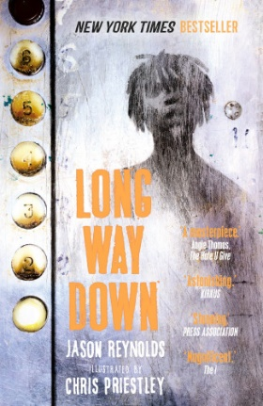
Will is only fifteen but he’s experienced more violence and loss than most people might in an entire lifetime. His big brother Shawn was recently shot dead, right in front of him, but as “everybody knows”, “gunshots make everybody deaf and blind especially when they make somebody dead”. While his mom mourns, Will knows what he has to do. He must follow the three rules: No crying. No snitching. Revenge.
The writing is crisp, clever and dazzlingly compact. With a whole family history and personally-charged societal issues conveyed with powerful precision. The line and page breaks are perfectly constructed words and phrases frequently have multiple meanings, and Chris Priestley’s raw and resonant illustrations are hauntingly powerful. Boys will love it! (14+).

Northern Lights – Philip Pullman 9781407154169
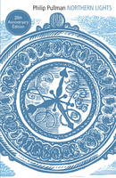
Read alongside the BBC drama, and head straight for the first book from ‘His Dark Materials’ trilogy by Philip Pullman. It tells the story of Lyra, a young girl with an exceptional destiny. Brought up in Jordan College, Oxford. Lyra uncovers a secret about her mysterious guardian Lord Asriel which leads to some dangerous questioning. It also marks the beginning of Lyra’s search for her friend Roger, a search that leads her to the ice kingdoms of the North, where armoured bears rule. Lyra’s courage and stubborn determination lead her on this mission of incredible danger in this brilliant and imaginative story.
The author’s vivid imagination and vision is so spectacular and moving that it will leave you almost speechless with admiration, and the amazingly diverse characters will be admired by all those who read about them. This book is completely spellbinding, a true classic.

Boy Nobody – Allen Zadoff 9781408327609
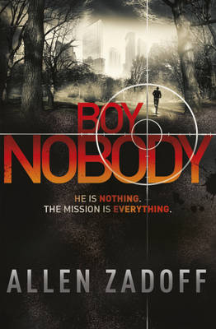
A gripping, high octane thriller which stretches nerves and keeps readers guessing as the taut drama unravels. No one knows much about the new boy in the class. He seems harmless and he fits in easily. He can make a good friend, but he leaves a deadly legacy. When Jack takes him home, he has no idea that his life will be changed forever. But the boy has done this before, and he is moving on and will do it again. But having no fear, sympathy or remorse begins to take its toll. Can Boy Nobody keep his memories under control? And what will happen if he can’t?
Perfect for fans of Jason Bourne, Robert Muchamore and Michael Grant.

Happy Christmas Reading!

